

use case diagrams



Advisor’s name: Mohammad Al Hajj

Course Name: Software Engineering

Course Code: CSCI317

Signature:

Instructor Notes: Date of approval:

April 7, 2022

Done by ali hamed

1220024

Table of Contents

Overview: 4

Goal: 4

Introduction: 4

What is the use case diagram? 4

Important point: 4

The description of the use case: 4

Use case: 4

Actor: 5

Association: 5

System: 5

Include: 6

Extend: 6

Dependency: 6

Generalization: 6

Information presentation: 7

The common things for users: 7

Login and Sign-up use case: 7

Profile use case: 8

Video posts use case: 9

Write posts use case: 10

Chat use case: 11

Alert and Ads use case: 12

Search process, view profiles and book a section within the store: 13

Store use case: 14

The specific things for users: 15

Admin use case: 15

Municipalities use case: 16

Narrative use case: 17

What is narrative use case? 17

Narrative use case for the store: 17

Narrative use case for the municipalities: 18

Narrative use case for Alert: 19

Conclusion: 20

References 20

# Overview:

The problem of waste accumulation is one of the biggest problems that any society may face. Therefore, in order to find an effective mechanism to solve this problem or even contribute to a large extent in solving it, **Clean&Green** application is the perfect project for that.

# Goal:

The aim of this paper is to clarify the idea of ​​requirements in a “use case diagram” method.

# Introduction:

## What is the use case diagram?

A use case diagram is a graphical depiction of a user's possible interactions with a system. A use case diagram shows various use cases and different types of users the system has and will often be accompanied by other types of diagrams as well. The use cases are represented by either circles or ellipses. The actors are often shown as stick figures. (Wikipedia, n.d.)

## Important point:

The main thing that must be constantly present during the use of the program, which is also a prerequisite for using the program is the login process.

## The description of the use case:

### Use case:

UML use case

A use case represents a user goal that can be achieved by accessing the system or software application. In Visual Paradigm, you can make use of the sub-diagram feature to describe the interaction between user and system within a use case by creating a sub-sequence diagram under a use case. You can also describe the use case scenario using the Flow of Events editor.

### Actor:

UML actor

Actor and use case can be associated to indicate that the actor participates in that use case. Therefore, an association correspond to a sequence of actions between the actor and use case in achieving the use case.

### Association:

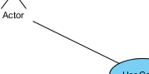

Actor and use case can be associated to indicate that the actor participates in that use case. Therefore, an association correspond to a sequence of actions between the actor and use case in achieving the use case.

### System:

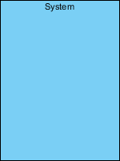

The scope of a system can be represented by a system (shape), or sometimes known as a system boundary. The use cases of the system are placed inside the system shape, while the actor who interact with the system are put outside the system. The use cases in the system make up the total requirements of the system.

### Include:

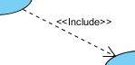

An include relationship specifies how the behavior for the inclusion use case is inserted into the behavior defined for the base use case.

### Extend:

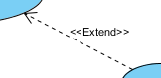

An extend relationship specifies how the behavior of the extension use case can be inserted into the behavior defined for the base use case.

### Dependency:

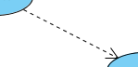

A dependency relationship represents that a model element relies on another model element for specification and/or implementation.

### Generalization:

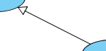

A generalization relationship is used to represent inheritance relationship between model elements of same type. The more specific model element shares the same specification with. the more general the model element but carries more details in extra.

To see more details and forms of the use case, you can go to the following website: (Paraim, n.d.)

# Information presentation:

## The common things for users:

### Login and Sign-up use case:

This image shows how the system provides users with the ability to submit an account registration request and how to log in and out.

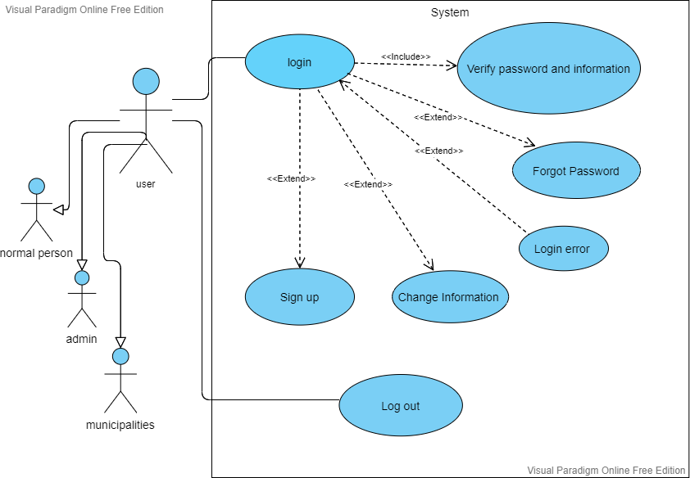

### Profile use case:

This image shows how the system offers users the ability to control their profile and how to search through the system sections.

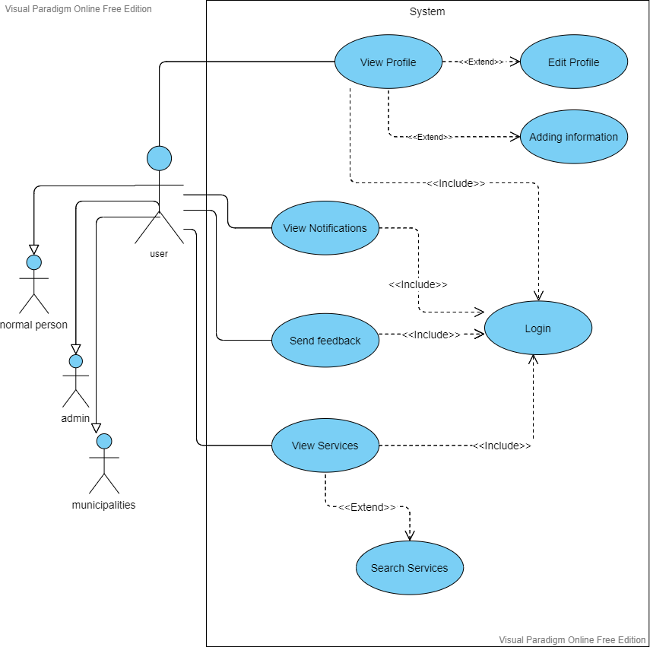

### Video posts use case:

Here we can see the things that the system allows users to do with regard to the topic of videos.

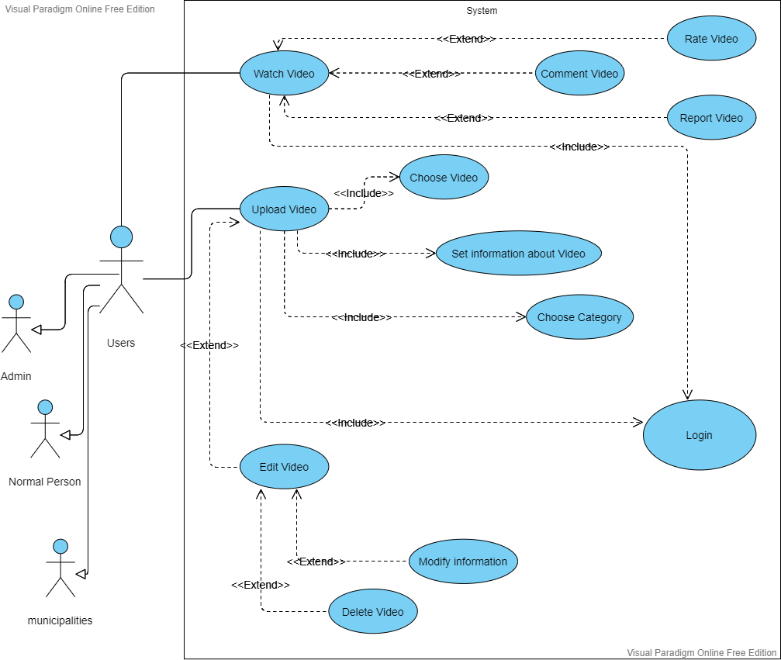

### Write posts use case:

This image shows users what they can do with writing posts.

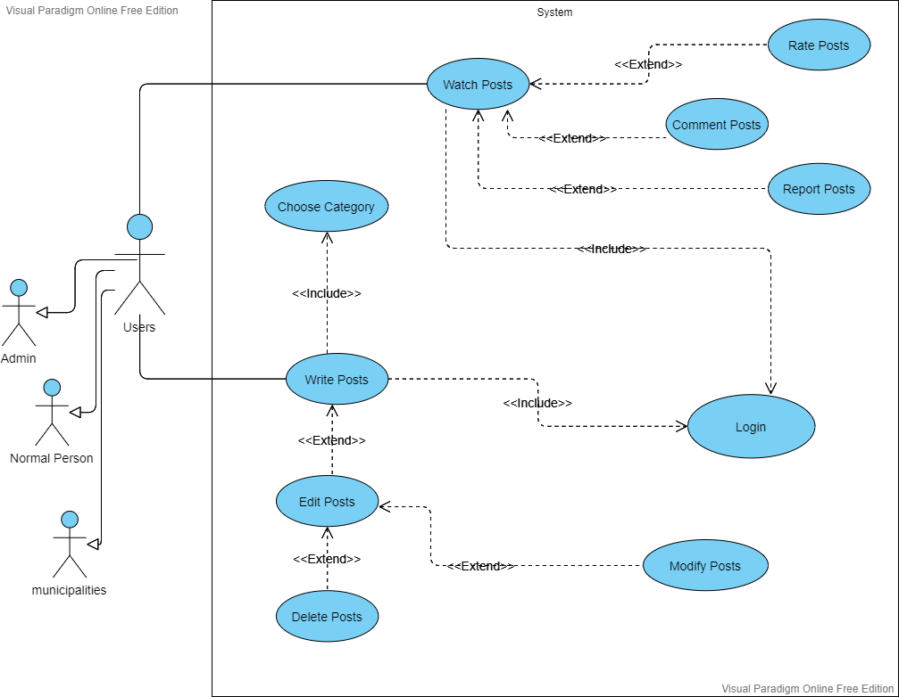

### Chat use case:

This image is intended to show what users can do in the in-app chat area.

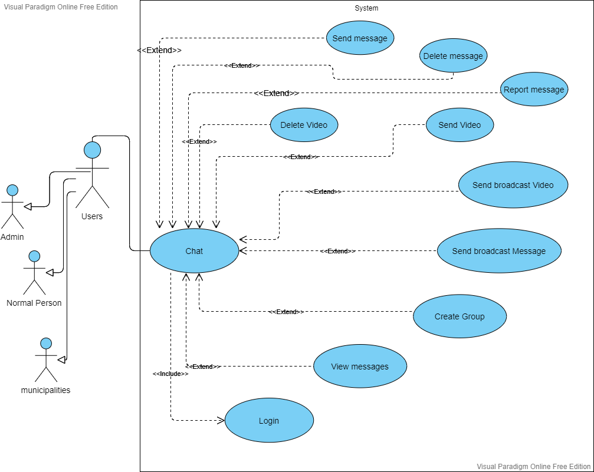

### Alert and Ads use case:

It has been previously clarified that this application contains an alarm that users can benefit from, and the program also contains advertisements aimed at making profit for the programmer (the owner of the application). This image shows what users can do about these two topics.

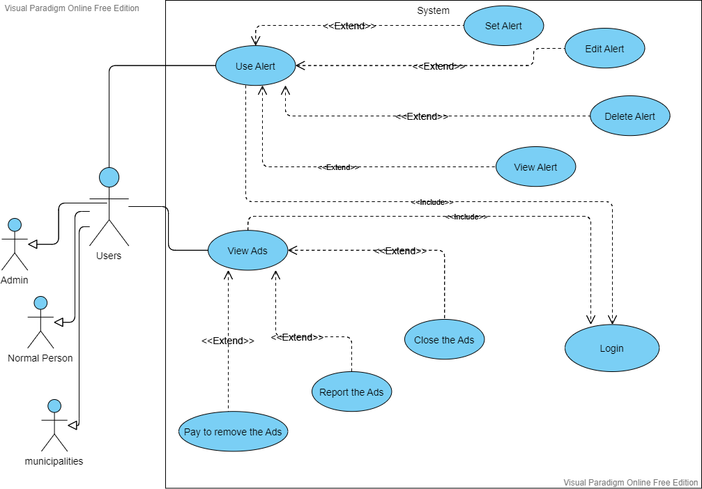

### Search process, view profiles and book a section within the store:

The thing that this image shows is the process of searching within the system for any inquiry and viewing some personal information of other users, in addition to booking a section within the store to be able to sell recyclable materials for profit to users.

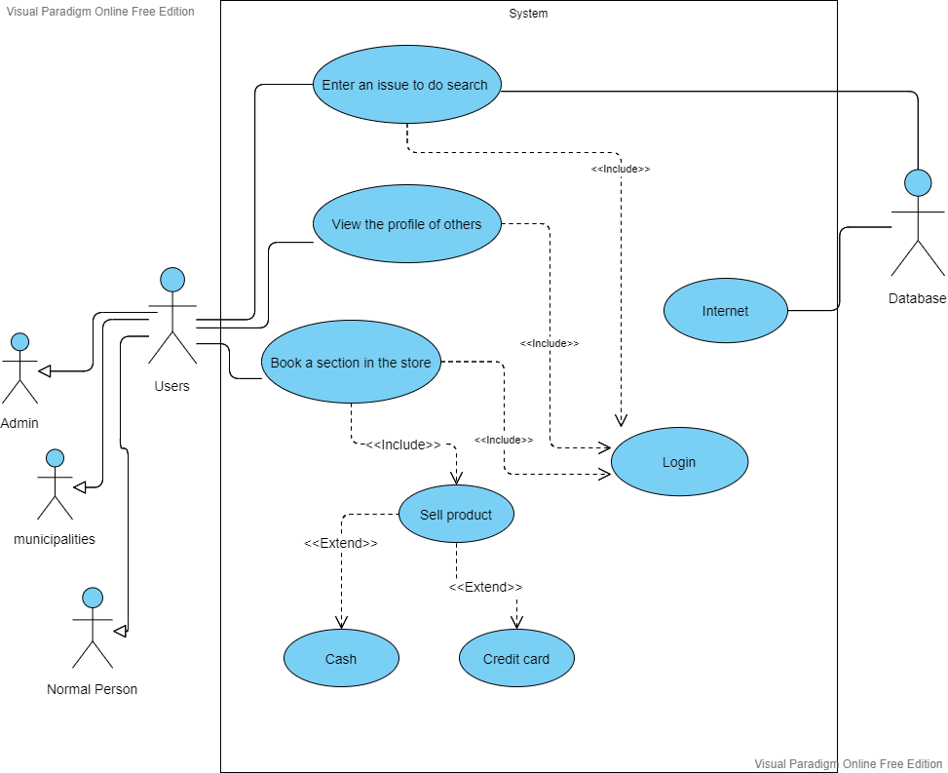

### Store use case:

This picture is to clarify in particular matters related to the purchase process within the store.

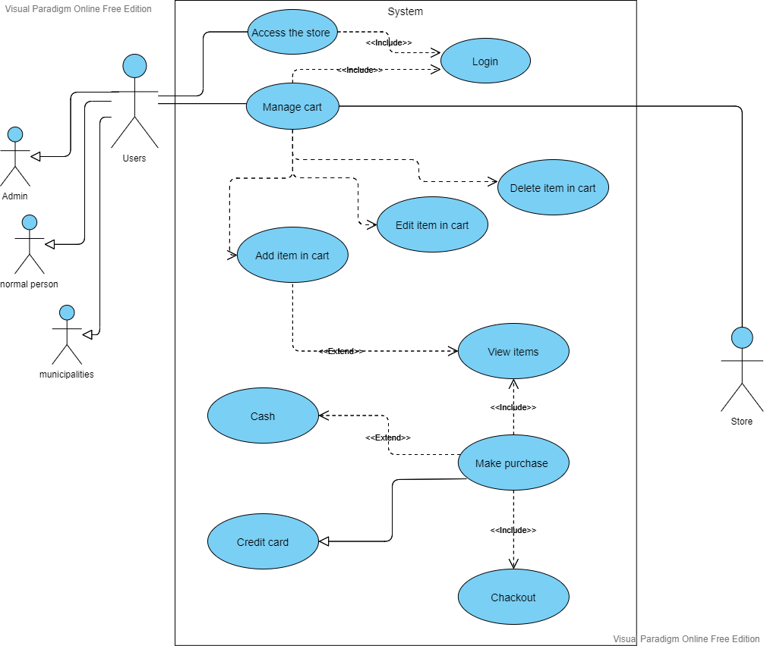

## The specific things for users:

### Admin use case:

All the edit will be add to the system and to the database.

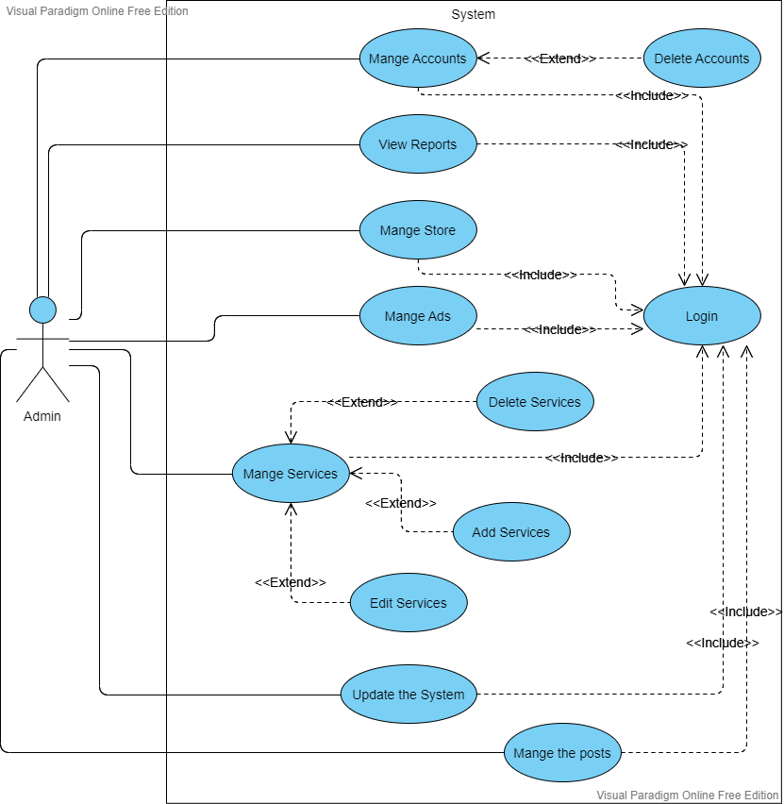

### Municipalities use case:

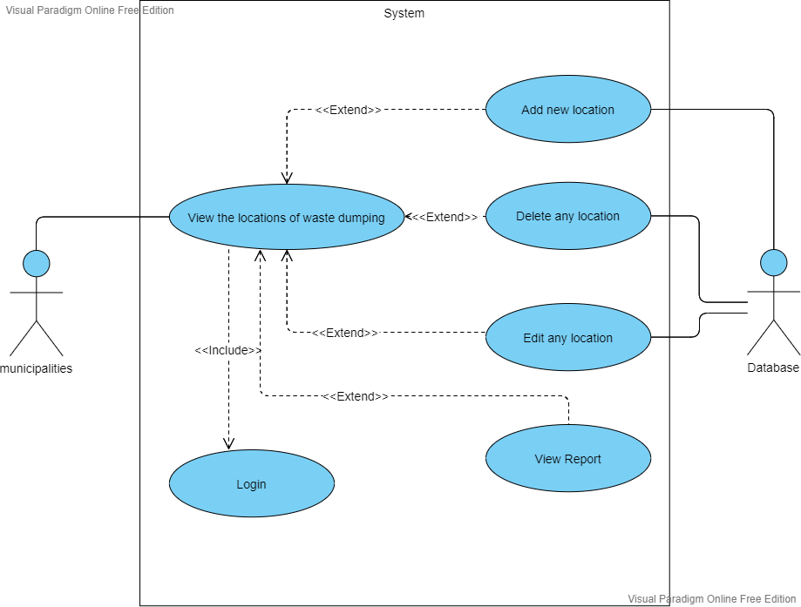

# Narrative use case:

## What is narrative use case?

A use case narrative is a largely text-based description of a use case that could be supplemented with decision trees or other easily understood notations. The description should be written in the use r’s language, and thus provides an important communication tool between developers of systems and the intended use rs. (GLOBAL, n.d.)

## Narrative use case for the store:

main actors:

1. Admin.
2. Normal user.
3. Municipalities.

secondary actors:

1. Store.

Precondition:

1. The user has sign up.
2. The user entered his name.
3. The user entered his email address.
4. The user entered his password.

Normal flow of action:

1. The user logs in.
2. The user entered their email addresses.
3. The user entered the password.
4. The user reserved a section in the store if they want to sell items.
5. The user added their bank account number if they want to buy or sell items using credit card.

Alternative flow of action:

1. The user may enter the wrong email.
2. The user may enter the wrong password.
3. The user may ask to change the password in case he forgot the original one.
4. The system will send him a verification message.
5. The user can forget to fill in the bank account number in order to transfer the money to him.
6. The user may fill in the wrong bank account number.
7. The system will send him a notification message.
8. The user may pay for wrong item.
9. The system should allow him to cancel the operation.

Postcondition:

1. The store should remove one item from the database every time a purchase is made.
2. The store should add one item to the database every time a product is added for sale.
3. The store should transfer the money between the users.

## Narrative use case for the municipalities:

main actors:

1. Municipalities.

secondary actors:

1. Database.

Precondition:

1. The Municipalities has sign up.
2. The Municipalities entered his name.
3. The Municipalities entered his email address.
4. The Municipalities entered his password.

Normal flow of action:

1. The Municipalities logs in.
2. The Municipalities entered their email addresses.
3. The Municipalities entered the password.
4. The Municipalities added new waste dumped locations.
5. The Municipalities edit the previous waste dumped locations.
6. The Municipalities deleted some of the previous waste dumped locations.

Alternative flow of action:

1. The Municipalities may enter the wrong email.
2. The Municipalities may enter the wrong password.
3. The Municipalities may ask to change the password in case he forgot the original one.
4. The system will send him a verification message.

Postcondition:

1. The system will add the information modified by the Municipalities.

## Narrative use case for Alert:

main actors:

1. Admin.
2. Normal user.
3. Municipalities.

secondary actors:

1. System

Precondition:

1. The user has sign up.
2. The user entered his name.
3. The user entered his email address.
4. The user entered his password.

Normal flow of action:

1. The user added the alarm.
2. The user may edit the alarm.
3. The user may delete the alarm.

Alternative flow of action:

1. The user may enter the wrong email.
2. The user may enter the wrong password.
3. The user may ask to change the password in case he forgot the original one.
4. The system will send him a verification message.
5. The user may set wrong alarm.

Postcondition:

1. The system will add the new modified to the database.
2. The system will activate the alarm on the time set by the user.

# Conclusion:

This paper explains in a simplified way to all the people who can see it how the system works in detail. Also, some references have been added that the reader can see, which will help him understand the idea more clearly and effectively.

# References

GLOBAL, I. (n.d.). *IGI GLOBAL*. Retrieved from https://www.igi-global.com/dictionary/use-cases-uml/37227#:~:text=A%20use%20case%20narrative%20is%20a%20largely%20text-based,developers%20of%20systems%20and%20the%20intended%20use%20rs.

Paraim, V. (n.d.). *Visual Paraim*. Retrieved from https://www.visual-paradigm.com/support/documents/vpuserguide/94/2575/84257_usecasediagr.html#uml-use-case

Wikipedia. (n.d.). *Use Case*. Retrieved from https://en.wikipedia.org/wiki/Use_case_diagram